*Heaven’s light is our guide.*

**Rajshahi University of Engineering and Technology**

**(RUET)**

**Department of Electrical & Electronic Engineering**

**Course no.** EEE2204

**Course title:** Electronics III Sessional

**Experiment no.** 03

**Experiment name:** Experimental study of precision half wave and full wave rectifier circuits using Op-Amp.

**Submitted to:**

**Dr. Md. Samiul Habib**

Associate Professor

Dept. of Electrical & Electronic Engineering,

Rajshahi University of Engineering and Technology.

**Submitted by:**

**Ashraf Al- Khalique**

**Roll:** 1801171; **Session:** 2018-2019

Dept. of Electrical & Electronic Engineering,

Rajshahi University of Engineering and Technology.

**Date of experiment:** March 10, 2021.

**Date of submission:** March 25, 2021.

**Experiment no**. 03

**Name of the Experiment:** Experimental study of precision half wave and full wave rectifier circuits using Op-Amp.

**Objectives:** Followings are the main objectives of this experiment,

1. To understand the theory of operation of precision half wave and full wave rectifier circuits.
2. To study the diode applications in precision half wave and full wave rectifier circuits.
3. To observe wave shapes that meet the precision half wave and full wave rectifier circuits’ needs.

**List of Components:**

1. Function Generator
2. DC power supply (61mV)
3. Resistors (1kΩ; 4 pieces)
4. Op- Amp (µA741; 2 pieces)
5. Diode (1N 4007; 2 pieces)
6. Oscilloscope
7. Project board
8. Connecting wires
9. Simulator (Multisim 11.0)

**Circuit diagram:**



***Fig 1.1:*** *Circuit diagram for precision half wave rectifier circuits using Op-Amp.*

**

***Fig 1.2:*** *Circuit diagram for precision full wave rectifier circuits using Op-Amp.*

**Waveshape:**

1. **Precision half wave rectifier circuits using Op-Amp:**

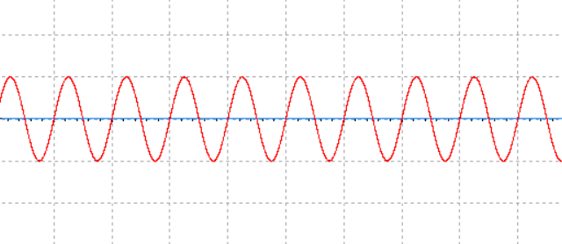

***Graph 1.1:*** *Input signal for* *precision half wave rectifier circuits using Op-Amp.*

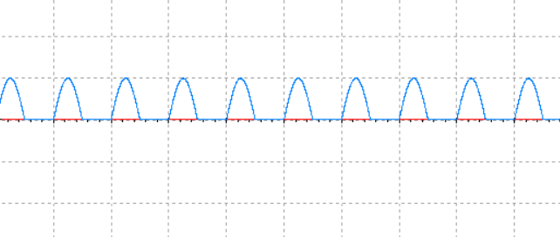

***Graph 1.2:*** *Output signal* *for precision half wave rectifier circuits using Op-Amp.*

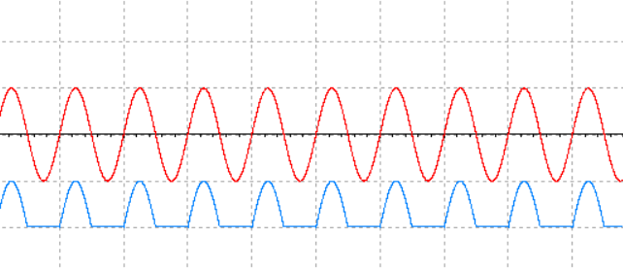

***Graph 1.3:*** *Input and output signal for precision half wave rectifier circuits using Op-Amp.*

1. **Precision full wave rectifier circuits using Op-Amp:**

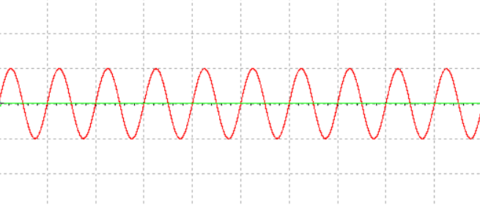

***Graph 2.1:*** *Input signal for precision full wave rectifier circuits using Op-Amp.*

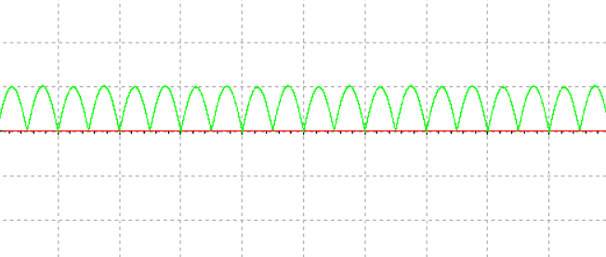

***Graph 2.2:*** *Output signal for precision full wave rectifier circuits using Op-Amp.*

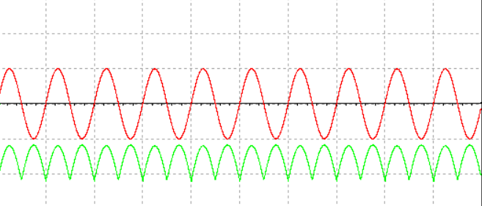

***Graph 2.3:*** *Input and output signal for precision full wave rectifier circuits using Op-Amp.*

**Result:**

In precision half wave rectifier circuit, in positive half cycle, output was almost equal to input but negative half cycle was completely clipped.

In precision full wave rectifier circuit, negative half cycle was inverted and was same as positive half cycle.

**Conclusion:**

For both precision half wave and full wave rectifier circuit, the desired output signal was obtained when large input signal was given.

In case of precision half wave rectifier circuit, R1, R2, R3 and R4 were equal in value. For positive half cycle, D2 was short circuited. Therefore, Vout is equal to Vin. On the other hand, for negative half cycle, D2 was open and D1 was short circuited. Vout becomes zero.

In case of precision full wave rectifier circuit, R1, R2, R3, R6, R7 were equal in value and R4 and R5 were double their value. For positive half cycle, D2 was short. So, source voltage and output of the first op-amp, both worked as an adder circuit where R5 was feedback for second op-amp. The output of this adder is equal to Vin. On the other hand, for negative half cycle, D2 was open. Vout was just inverted.